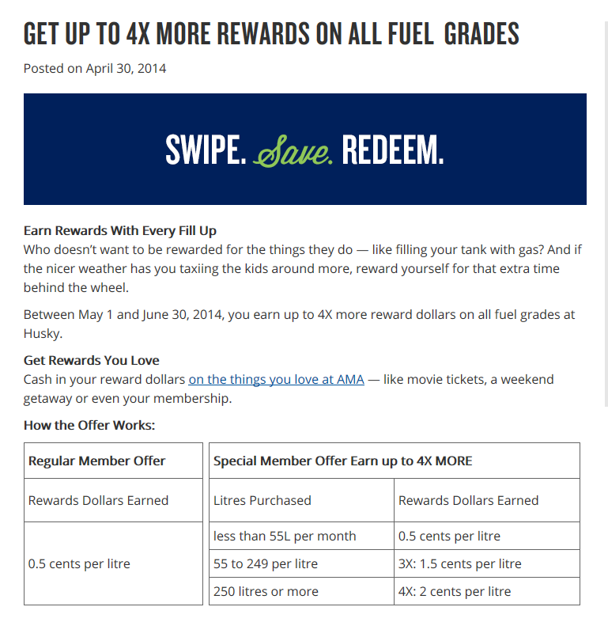

Pump up the savings

Earn reward dollars with every fill

1 cent per litre

1.5 cents per litre

Update this URL:

http://ama.ab.ca/2014/04/30/get-up-to-4x-more-rewards-on-all-fuel-grades/?utm_source=multi&utm_medium=shortlink&utm_campaign=AMARewards

Get paid every time you fill your gas tank.

Now that’s rewarding!

You’ll get paid back every time you fill your gas tank. That’s right. Just swipe

your AMA card when you fuel up at Husky, and you’ll earn valuable reward

dollars to spend at AMA.

Plus earn 3% in reward dollars on eligible purchases at the Convenience Store and Husky House Restaurants and 1% on lottery tickets.

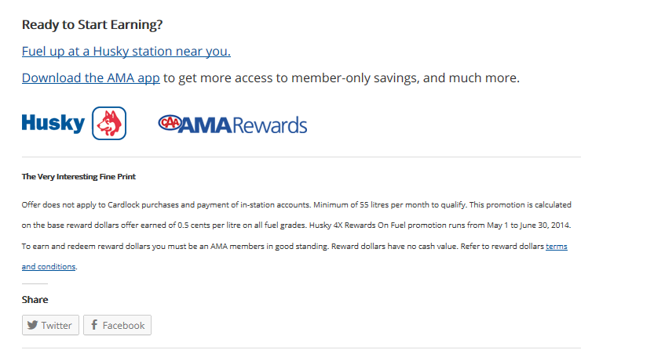

Eligible purchases do not include liquor, tobacco, gift cards and certificates, and payment of in-station accounts or purchases made with Husky Route Commander (cardlock). Subject to change without notice.